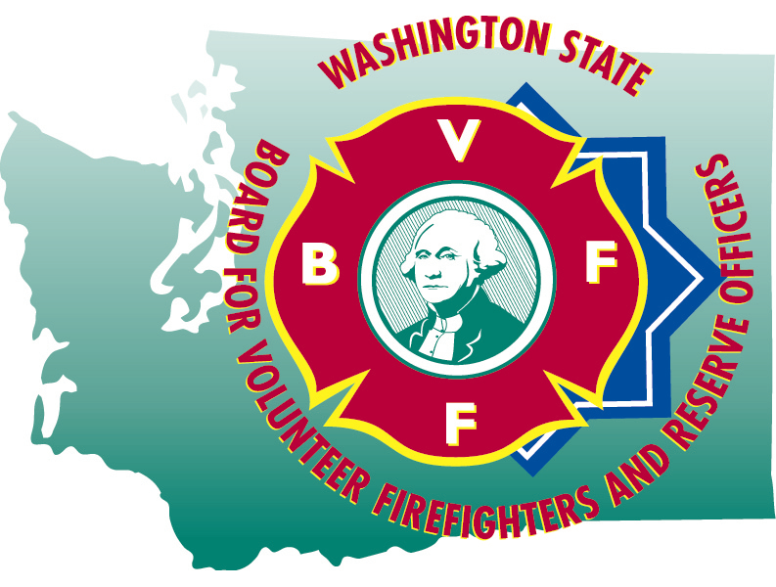
HAILEY BLANKENSHIP
Executive Secretary

STATE OF WASHINGTON

BOARD FOR VOLUNTEER FIREFIGHTERS & RESERVE OFFICERS
PO Box 114•Olympia WA 98507•(360) 753-7318•FAX (360) 586-1987•Toll Free (877) 753-7318
Website:www.bvff.wa.gov

Martin Spani
Board Chair

April 21, 2025

STATE OF WASHINGTON

BOARD FOR VOLUNTEER FIREFIGHTERS & RESERVE OFFICERS
PO Box 114•Olympia WA 98507•(360) 753-7318•FAX (360) 586-1987•Toll Free (877) 753-7318
Website:www.bvff.wa.gov

AGENDA

CALL TO ORDER

CORRECTIONS TO THE AGENDA

INTRODUCTION OF GUESTS

READING OF THE MINUTES OF THE January 27, 2025 REGULAR MEETING

FIRST HEARING OF THE PUBLIC PRESENT

OLD BUSINESS

- Update of the database project
- Update on the PPD appeal for Gregory Laycock
NEW BUSINESS

- Review of the 2025 Supplemental and 2025-27 biennial budget items
- Review of PPD Award for Michelle Harbaugh
- Review of a PPD Award for Saul Perez
- Review of Fire Insurance Premium Tax Transfer policy
- Review of the Secretary’s leave and pay records
- Review of administrative expense vouchers

- Review and approval of retirement forms

- Update on Board seats and Attorney General Representation

GOOD OF THE ORDER

SECOND HEARING OF THE PUBLIC PRESENT

MOTION FOR ADJOURNMENT

