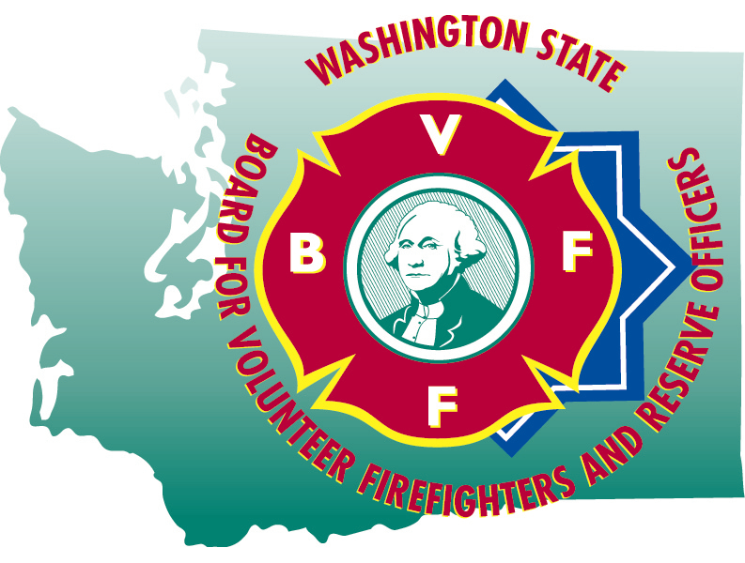
HAILEY BLANKENSHIP
Executive Secretary

STATE OF WASHINGTON

BOARD FOR VOLUNTEER FIREFIGHTERS & RESERVE OFFICERS
PO Box 114•Olympia WA 98507•(360) 753-7318•FAX (360) 586-1987•Toll Free (877) 753-7318
Website:www.bvff.wa.gov

Martin Spani
Board Chair

October 21, 2024

STATE OF WASHINGTON

BOARD FOR VOLUNTEER FIREFIGHTERS & RESERVE OFFICERS
PO Box 114•Olympia WA 98507•(360) 753-7318•FAX (360) 586-1987•Toll Free (877) 753-7318
Website:www.bvff.wa.gov

AGENDA

CALL TO ORDER

CORRECTIONS TO THE AGENDA

INTRODUCTION OF GUESTS

READING OF THE MINUTES OF THE July 22, 2024 REGULAR MEETING

FIRST HEARING OF THE PUBLIC PRESENT

OLD BUSINESS

- Update of the database project
- Update on pension benefit increases
- Update on LODD claim appeal for Alan Basso
- Update on the PPD appeal for Gregory Laycock
NEW BUSINESS

- Presentation and discussion with Office of the State Actuary
- Presentation and discussion with Washington State Investment Board
- Review of the 2023 performance survey results
- Review of the Secretary’s leave and pay records
- Review of administrative expense vouchers

- Review and approval of retirement forms

GOOD OF THE ORDER

SECOND HEARING OF THE PUBLIC PRESENT

MOTION FOR ADJOURNMENT

