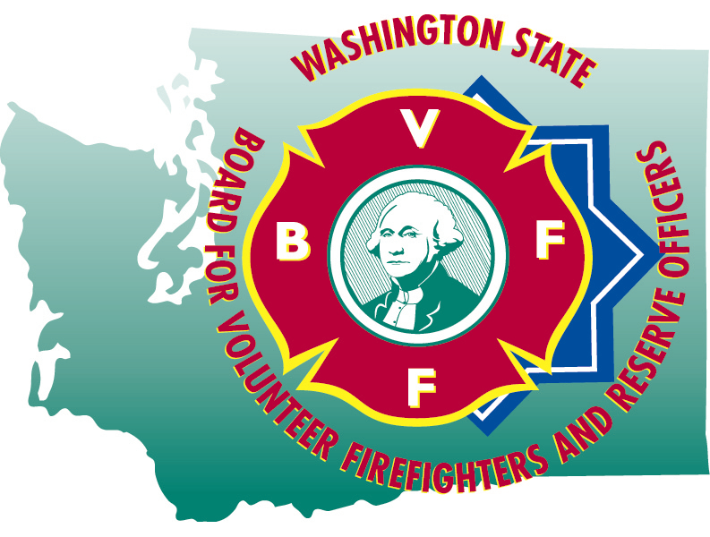
HAILEY BLANKENSHIP
Executive Secretary

STATE OF WASHINGTON

BOARD FOR VOLUNTEER FIREFIGHTERS & RESERVE OFFICERS
PO Box 114•Olympia WA 98507•(360) 753-7318•FAX (360) 586-1987•Toll Free (877) 753-7318
Website:www.bvff.wa.gov

Martin Spani
Board Chair

July 21, 2025

STATE OF WASHINGTON

BOARD FOR VOLUNTEER FIREFIGHTERS & RESERVE OFFICERS
PO Box 114•Olympia WA 98507•(360) 753-7318•FAX (360) 586-1987•Toll Free (877) 753-7318
Website:www.bvff.wa.gov

AGENDA

CALL TO ORDER

CORRECTIONS TO THE AGENDA

INTRODUCTION OF GUESTS

READING OF THE MINUTES OF THE April 21, 2025 REGULAR MEETING

FIRST HEARING OF THE PUBLIC PRESENT

OLD BUSINESS

- Update of the database project
- Update on the PPD appeal for Gregory Laycock
- Review of the 2025 Supplemental and 25-27 Biennial budget items
- Review of Fire Insurance Premium Tax Transfer policy
NEW BUSINESS

- 2025 Biennial Audit
- Review of the Secretary’s leave and pay records
- Review of administrative expense vouchers

- Review and approval of retirement forms

GOOD OF THE ORDER

SECOND HEARING OF THE PUBLIC PRESENT

MOTION FOR ADJOURNMENT

